A

Project Report on

**“CDAC AT A GLANCE”**

Submitted in partial fulfillment of the requirements of

E Diploma in Advanced Computing

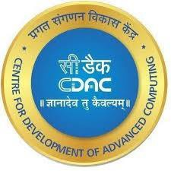

Submitted By

PG-DAC

September 2022

Ms. Bhawana Tiwari (220910120010)

Mr. Aman Jain (220910120003)

Mr. Eqtedar Afzal (220910120023)

Mr. Tarun Namdev (220910120052)

### Guided By

**Mr. Pankaj Kumar Mahto**

Faculty, CDAC Delhi

Centre for Development of Advanced Computing Delhi

### CERTIFICATE

This is to certify that the Report work entitled

**“CDAC AT A GLANCE”**

Has been duly completed by the following students under my

guidance, in a satisfactory manner as a partial fulfillment of the requirement for the award of the E- Diploma in Advanced Computing, Delhi

Submitted By

September 2022

Miss Bhawana Tiwari (220910120010)

Mr. Aman Jain (220910120003)

Mr. Eqtedar Afzal (220910120023)

Mr. Tarun Namdev (220910120052)

**Mr. Ankit Khurana Mr. Pankaj Kumar Mahto**

**Senior Technical Officer Senior Project Engineer**

**Declaration**

I declare that this written submission represents our ideas in our own words and where others' ideas or words have been included, we have adequately cited and referenced the original sources. We also declare that we have adhered to all principles of academic honesty and integrity and have not misrepresented or fabricated or falsified any idea/data/fact/source in my submission. We understand that any violation of the above will be cause for disciplinary action by the Institute and can also evoke penal action from the sources which have thus not been properly cited or from whom proper permission has not been taken when needed.

(Bhawana Tiwari 220910120010)

(Aman Jain 220910120003)

(Eqtedar Afzal 220910120023)

(Tarun Namdev 220910120052)

**Date:**13/03/2023

# ACKNOWLEDGEMENT

We are heartily thankful to our guide Prof. **Mr. Pankaj Kumar Mahto sir**, for his

guidance, patience and support. We consider ourself very fortunate for being

able to work with very considerate and encouraging professor like him. Without

his offering to complete these study work, we should not finished our project. It

is also our duty to record thankfulness to our whole CDAC department for their

help in needs.

Our special thanks to our parents and all of friends for help us exchanging any

ideas and give the enjoyable study environment. At last we special gratify to

almighty God for blessing us with the hidden power to complete this study work.

**PROJECT TEAM**

Miss. Bhawana Tiwari (220910120010)

Mr. Aman Jain (220910120003)

Mr. Eqtedar Afzal (220910120023)

Mr. Tarun Namdev (220910120052)

### Contents

|  |  |  |  |
| --- | --- | --- | --- |
| **Chapter** | | **Contents** | **Page No.** |
| **1** | | **Abstract** | **8** |
| **2** | | **INTRODUCTION:** Give at least two to three sentences about your project. | **9** |
|  | | **2.1 Description *(Brief description of project)*** The main functionality of the project should be explained in brief | **9** |
|  | | **2.2 Problem Formulation *(Explain the problem)*** | **10** |
|  | | **2.3 Motivation *(need of the project)***: List the various approaches along with its drawbacks for solving the problem and briefly explain the approach used for your project. | **10** |
|  | | **2.4 Proposed Solution:** Explain the method/technique used for solving the problem and how it overcomes the drawbacks mentioned under heading 1.3. Also explain how the project is going to help end users. | **10** |
|  | | **2.5 Scope of the project *(scale/range of your project)*:** Extent of how far your project can be completed. This can be in terms of domain or application related constraints/limitations. | **11** |
| **3** | **SYSTEM ANALYSIS** | |  |

|  |  |  |
| --- | --- | --- |
|  | **3.1 Functional Requirements *( write requirements of the project)*** Should follow the IEEE SRS format | **12** |
|  | **3.2 Non Functional Requirements** Should follow the IEEE SRS format | **13** |
|  | **3.3 Specific Requirements *(Hardware and software requirements)*** | **13** |
| **4** | **ANALYSIS MODELING** | **15** |
|  | * 1. **Use-Case Diagrams and description**   2. **Activity Diagrams**   3. **Class Diagram** | **15**    **to**  **16** |
| **5** | **DESIGN** | **17** |
|  | **5.1 Data Modeling *(E-R Model, Relational tables with its associated Data dictionary****)* ER Diagram normalized till the third normal form accompanied by the respective data dictionary table should be included | **17** |
|  | **5.2 Architectural Design (*Project Flow /architecture with description)*** | **18** |

|  |  |  |
| --- | --- | --- |
|  | **5.2 User Interface Design** GUI for your project (Screenshot) | **19**  **to**  **22** |
| **6** | **TESTING** | **25** |
| **7** | **RESULTS AND DISCUSSIONS** | **26** |
| **8** | **CONCLUSIONS** | **27-29** |

Appendix

**ABSTRACT**

# CDAC AT A GLANCE is a centralized website which aims in developing a e-learning platform to access all study related data at a single platform which is required for their pg-diploma course. This website includes various features getting all the contents regarding course ,download feature is also available so as student can collect data at one place.Faculty will be able to provide course regarding information over here.It lessens the work of faculties as well as better way for students to get updated . To eliminate the manual system, this website has been developed which will handle all the current issues faced by the students.

It has a facility for admin login through which the admin can monitor the whole system. It has a facility where students after logging in to their accounts can see the syllabus regarding contents issued .Overall, this project of ours is being developed to help the faculty of the organisation and the students pursuing the course.

# Chapter 2

**Introduction**

The main idea of this project is to provide flexible and convenient way for learners to access educational materials and engage in online learning activities. E-learning platforms can be used by a wide range of learners, including students, professionals, and individuals seeking personal development opportunities. They offer a self-paced, on-demand learning experience that allows learners to access educational content anytime, anywhere, and at their own pace.

##### Description

Cdac at a glance, is a e-learning platform is a web-based software tool that enables the delivery of educational materials and management of learning experiences. E-learning platforms are designed to provide a flexible and convenient way for learners to access educational materials and engage in online learning activities. Admin can create, update and delete users details , and also can manage task related to adding new courses , subjects introduced. Instructors can create course content, set assignments and assessments, and track student progress. Students can access the site through registering on it and on successful registration will also receive email. Students can then login through their credentials to retrieve different study materials which are arranged as a module wise on the portal.We have also kept the change password through email otp generation if in case student forgets the password.

##### Problem Formulation

In today’s world when everything is shifting towards e-platform, e-learning platform can take place literally everywhere and at any time for students doing distant learning.

Students and educators face problem if the there is manual management of the contents,data it consumes lots of time efforts and sometime data can get misplaced also as it is manually being managed

##### Motivation

Idea behind developing this website was because we a students were facing lots of problem to get content regarding our diploma course.As faculties are assigned with multiple task so sometimes we used to get data bit late.Sometimes data used to get misplace.So the main idea was to lessen the burden of faculty and to provide facilties for student to get all content at one place which will reduce the time involved in searching for contents and will enhance learning.

* 1. **Proposed System**

CDAC at a Glance is an online platform designed to facilitate learning through the use of digital technologies. The proposed system of an e-learning platform should include the following components:

**User Interface:** The user interface should be intuitive and easy to use. The platform should be designed to accommodate users with varying levels of technical expertise.

**Content Management:** The e-learning platform should have a content management system that allows for the easy creation, uploading, and management of various types of content. This could include video lectures, text-based materials, and assignments.

**User Management:** The system should have a user management system that allows for easy registration, login, and authentication. It should also provide tools for user profiling, course enrollment, and progress tracking.

##### Scope

E-learning platforms are used in education to provide students with online learning opportunities. They offer flexible, on-demand learning opportunities that can be customized to meet the needs of individual learners and organizations. It provides opportunities for learners to collaborate with one another as well as other experts in their respective,fields.

# Chapter 3

**System Analysis**

## Functional Requirements

* + 1. **Login of Admin**
       - The Admin will be able to manage all the users.
       - The Admin will be able to view,add and delete users.
       - The Admin will be able to add and delete courses.
       - The Admin will be able to view all faculties and students.
       - Can change password

## Login of Faculty

* + - * The Faculty will be able to get registered and login.
      * The Faculty will be able to upload content and retrieve assignments submitted by students.
      * The Faculty will get notifications via E-mail after he/she registered.
      * The Faculty will be able to upload his/her teaching content.
      * The Faculty will be able to change password via email otp verification.

## Login of Student

* + - * The Student will be able to get registered and login.
      * The Student will be able to view the teaching content uploaded by faculties.
      * The Student will get notifications via E-mail after he/she registered.
      * The Student will be able to upload assignments.
      * The Student will be able to change password via email otp verification.
  1. **Non-functional Requirements**

#### Performance Requirements

The system should store all the database records of assigned project, assigned task, completed task, task status and requested task and the application should be available for use 24*7 through the server. Also, the application should be user friendly with a proper user interface which makes it easy for the user to understand. All the options should be present in properly accessible places for user convenience.

#### Safety Requirements

All login ids and passwords of the admin, faculty and students should be protected for privacy using whatever constraints required in the database or the application.

#### Security Requirements

All passwords of the administrators should be protected for privacy using whatever constraints required in the database or the application. The database should be protected from attacks and unauthorized access. The interface should be protected from attacks. All passwords should be stored as a secure hash of the administrator password.

###### 3.3 Software Quality Attribute

###### 3.3.2 Availability

The system should run on a variety of operating systems that support

the Java language. The system should run on a variety of hardware.

###### Accessibility

The software will be accessible to admin.

###### Compatibility

The software will be compatible with multiple platforms.

###### Durability

The software will be tested for working with multiple users.

###### Effectiveness

The software will be made to handle operations effectively.

###### Maintainability

The system should be easy to maintain. There should be a clear separation between the interface and the business logic code. There should be a clear separation between the data.

# Chapter 4

**Analysis Modeling**

* 1. **Use Case Diagram: -**

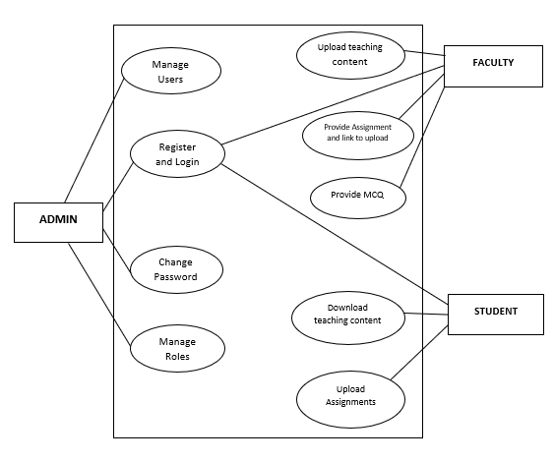

**Flow Chart :**

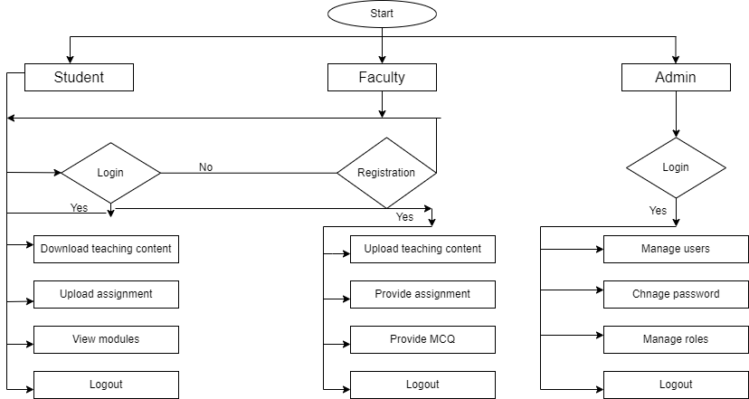

# Chapter 5

**DESIGN**

* 1. **Data Modeling :**

**ER Diagram :**

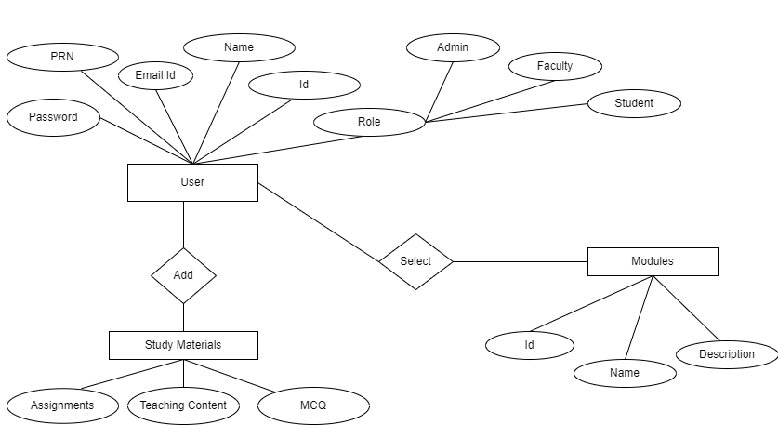

**5.2 Architectural Design**

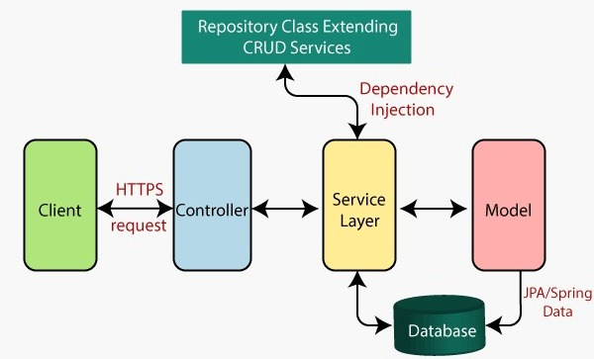

**5.3 User Interface Design(GUI):**

**Home Page :**

This is the home page of our website cdac-at-a-glance.In our home page we have

Provided with the feature of register , login as faculty,student or admin ,also we have provided with functionality of forgot password.Other features included in our home

page is the hyperlinks to official website,contact mails in the footer section.

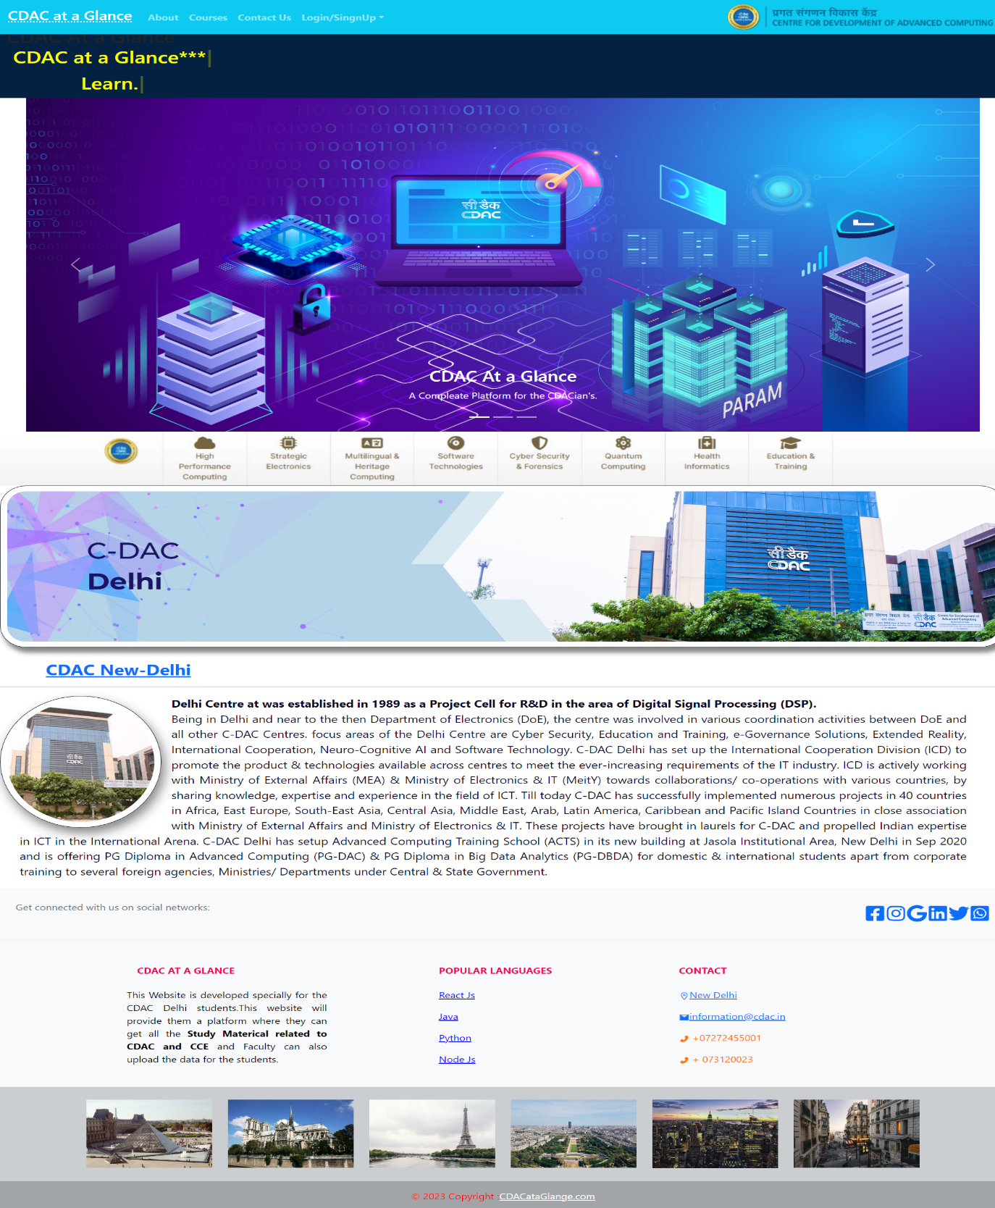

**Registration Page :**

The registration page show all the required details to be add in the database for the new user to able to access the website . After filling all the details click on the submit button for registration. There is another reference link given for the user for if the user is already register with the application system.

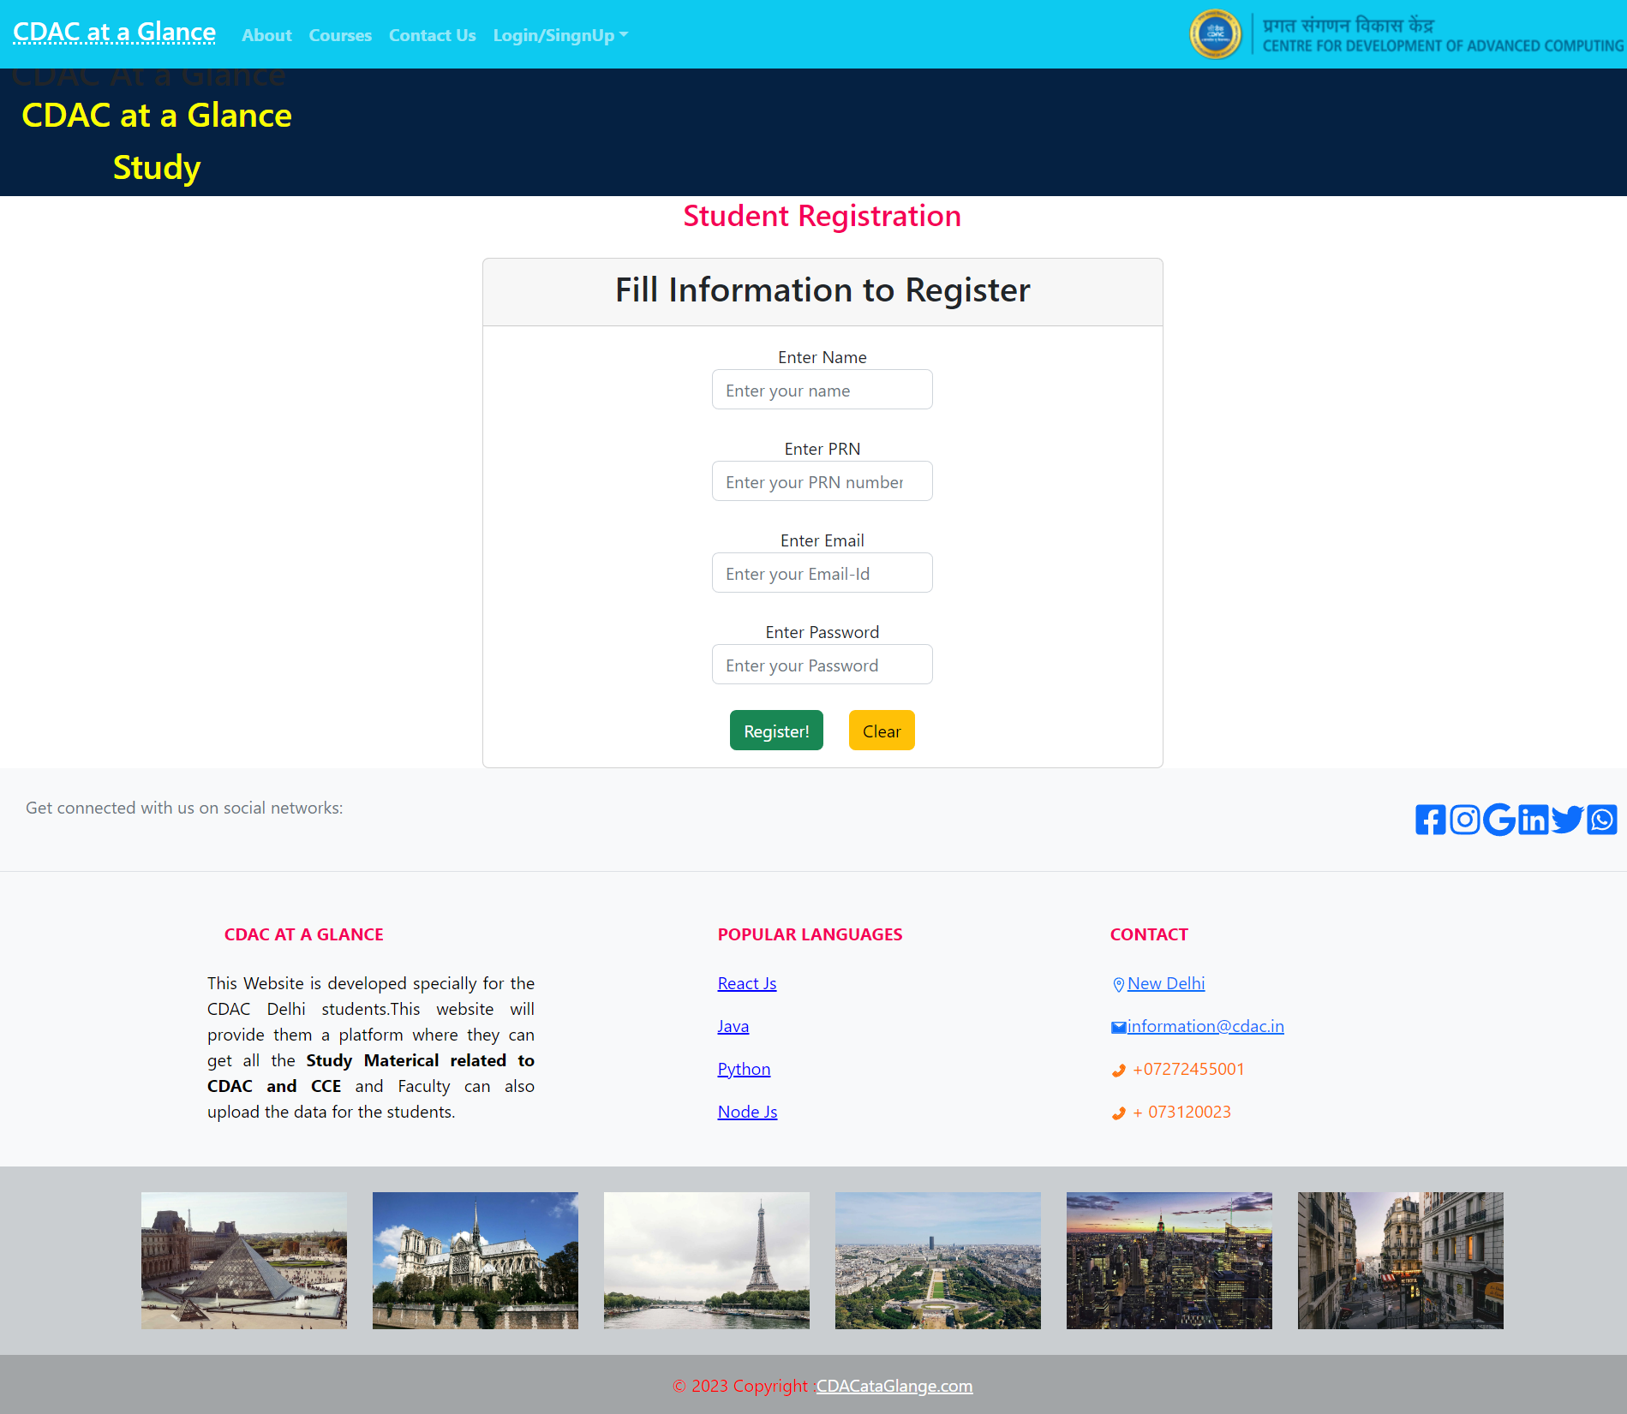

**Registration Confirmation Mail Page :**

After successful registration you will receive this type of mail

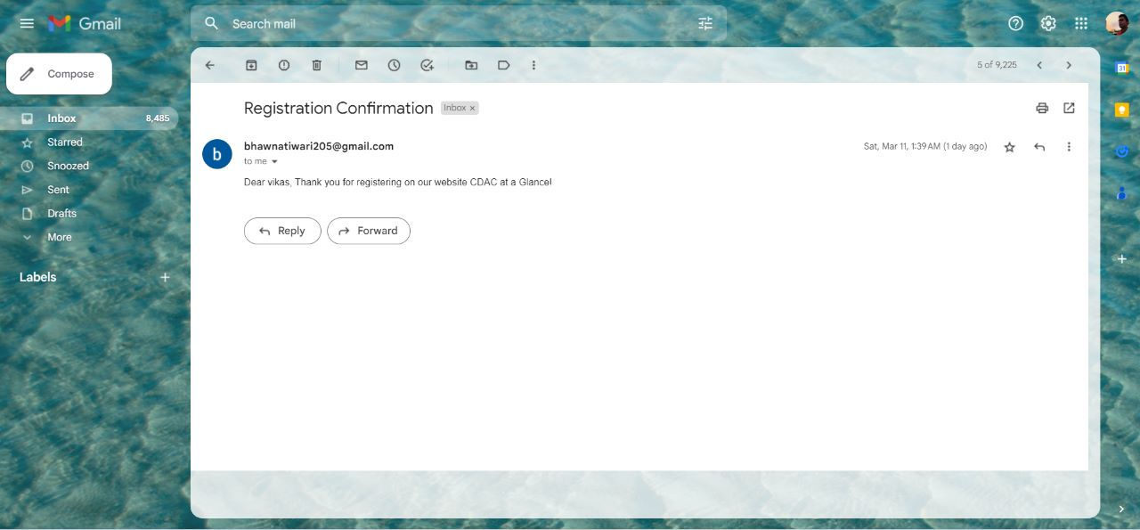

**Login Page :**

The sign-in page is shown below which has the username, password.Correct username, password will allow the user to login into the account. If the user will fail to put correct details the system will not allow to login, and the pop-up of Invalid username and

password will be generated. Also, there is a reference link given for the user if the user forgot their password and can change their password through email otp veriffication.

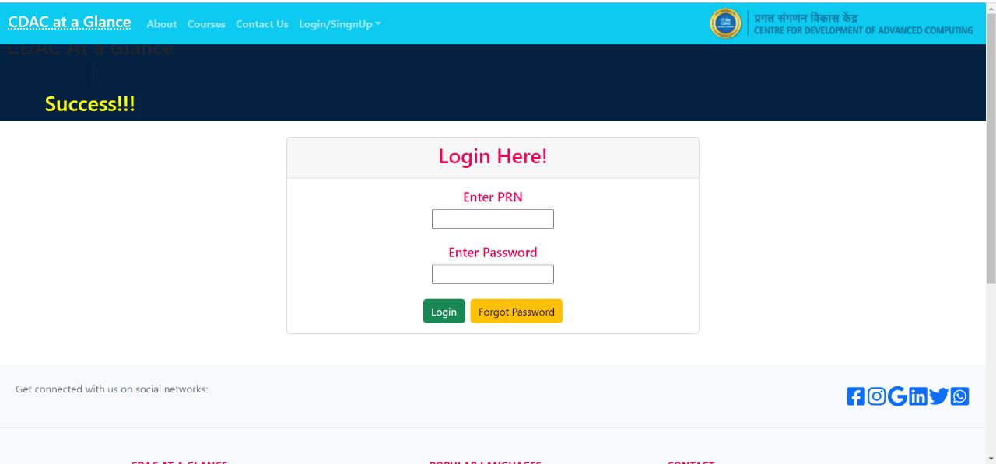

**Forgot Password Page:**

User will enter its registered mail id and then will receive otp on the email.Then the otp will be verified Through matching it from otp stored in session, if validated then the user will be able to change password that will reflect in database.

If student/faculty **forget password :**

# 

Chapter 6

**TESTING**

##### Type of Testing used

###### Alpha Testing: -

Alpha testing allows the team to test the software in a real-world environment. One of the reasons to do alpha testing is to ensure the success of the software product. Alpha testing validates the quality, functionality of the software, and effectiveness of the software before it released in the real world. It is the most common type of testing used in the Software industry. The objective of this testing is to identify all possible issues or defects before releasing it into the market or to the user.

# Chapter 7

**Results and Discussions**

The main idea of an e-learning platform is to provide a digital environment where

learners can access educational resources and courses anytime and anywhere using the internet. The platform can be designed to offer a variety of courses and can include a range of interactive features to engage learners such as video lectures, online quizzes, and discussion forums. The purpose of an e-learning platform is to make education more accessible, flexible, and cost-effective for learners, while providing a customized learning experience that can improve learning outcomes.

# Chapter-8 Conclusions

In today’s fast growing and busy world, everybody looks for an easy and convenient e-learning platform. Getting everything at one platform is the main thing which everyone looks for in today’s busy life. Providing high-quality, interactive e-learning content and variety of methods, including lab exams, performance-based assessments, mcq and test series, to ensure that learners have acquired the knowledge and skills needed to succeed in their chosen field was the main motto of CDAC at a Glance, so we came up with this idea. We hope this platform will help users get everything they need. Working on this project was fun and insightful at the same time as we got to learn a lot of things.

**FUTURE SCOPE OF THE PROJECT**

The project is easily extensible and can be improved by further incremental releases of the same. In future we Faculty can add assignments and their links which will reflect students directly by login in their student portal, and student can access and upload the assignment on the same link. We can maintain the large data base and make centralized for all the CDAC centers all over the India.

### Appendix

* MySQL is an open-source relational database management system (RDBMS).
* Spring Boot is an open-source Java-based framework used to create microservices.
* Java Persistence API. It’s a specification which is part of Java EE and defines an API for object- relational mappings and for managing persistent objects.
* Spring Tool Suite is an Eclipse-based development environment (IDE) to develop spring applications. It provides a ready-to-use environment to implement, run, deploy and debug the application.